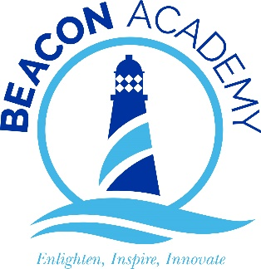

My Week of Work

8th – 12th June

Name |  | Form

What do you need to do?
Date Completed
Register with Learn Live https://learnliveuk.com/my-week-of-work/
Attend Introduction to My Week of Work
Choose one Oak National Academy session to attend during the week to develop your insight into the world of work and/or develop your employability skills (Page 3 and 9 have the schedule)
Attend one Learn Live virtual broadcast
(this must to be attended at the exact time shown on the Learn Live timetable – PAGE 3)
Complete the Be Ready ‘Personal Brand’ employability unit
Add notes to ‘My Week of Work Diary’ about sessions attended and reflections

Schedule
Oak National Academy website
Monday | Tuesday | Wednesday | Thursday | Friday
Introduction to My Week of Work Session | Meet the Team: Human Resource | Meet the Team: Marketing Session | Recruitment | Meet the Boss: Leadership
Investigate the sectors (1) Session | Work Life Balance Session | Innovation & Creative Thinking | HR: Recruitment | CV Creation
Investigate the sectors (2) | Mental Health & Well Being Session | Marketing Campaigns | Understanding Entrepreneurship: | Employability Skills in Everyday Life:
Insight into the World of Work | Work skills and reflection journal | You as a Brand! | Project Planning | Reflection of the week

Compulsory
You choose ONE other session to attend
Learn Live
 | Tuesday | Wednesday | Thursday | Friday
10:00am – 12:00pm | Health & Social Care | Engineering / Manufacturing | Energy & Renewables
12:00pm – 1:00pm | Health and Wellbeing Videos | Bonus Slot | Bonus Slot
1:00pm – 3:00pm | Creative & Digital | Construction | Bonus Slot | Your Next Steps
*Each day is hyperlinked to take you to the correct Learn Live webpage
Introduction to My Week of Work Session
Aim
- to understand the outline of the week and how you can access the careers education and the opportunity to gain insight into the world of work and develop employability skills
Make notes on the session below to help you access this Week of Work
Add screen shot from the session
Add title of the session you chose to attend and the day it was scheduled
What was the point of the session?
What did you learn?
How will this session influence you in the future when thinking about your next steps?

Add screen shot from the session
Reflection of the week Session
Aim
- to review week’s learning and skills development
Add any notes which you think are relevant
What did you learn?
How will this session influence you in the future when thinking about your next steps?

Add screen shot from the session
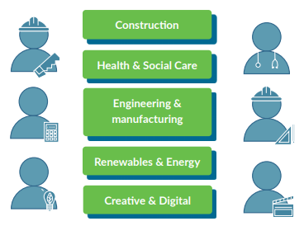
Add title of the Learn Live session you chose to attend and the day it was scheduled
What sector was the session focused on?
What did you learn?
Did you ask a question? If yes, what was it? Was it answered?
How will this session influence you in the future when thinking about your next steps?

Add screen shot from the session
Be Ready Certificate
Add a screen shot of your Be Ready certificate

Oak National Academy Timetable – Detailed overview
Compulsory sessions to introduce the week of sessions and reflect on experiences during the week
Monday | Tuesday | Wednesday | Thursday | Friday
1. Introduction to My Week of Work Session Aim: Pupils to understand the outline of the week and how they can access the careers education and the opportunity to gain insight into the world of work and develop employability skills | 1. Meet the Team: HR Exploring a ‘typical day’ Session aim: pupils to understand what a day in a specific working environment looks like | 1. Meet the Team: Marketing Session Aim: pupils will gain an understanding of the roles and responsibilities of a Marketing department | 1. Recruitment Session aim: pupils to understand skills that employers are looking for and that different roles will require different skills/qualities/ attributes. | 1. Meet the Boss: Leadership Pupils to understand leadership and traits of successful leaders pupils to understand how to make effective decisions around career management and development Skills Development & Showcase: Create a presentation/video to apply for the imaginary role of youth community engagement/fundraising lead at a local community group
2. Investigate the sectors (1) Session Aim: Pupils to explore key sectors to better understand key LMI information and the range of job roles/opportunities in these sectors | 2. Work Life Balance Session Aim: pupils to understand the issue of work life balance and how employers and employees approach this Skills Development & Showcase: pupils to design a poster to promote work-life balance in the workplace | 2. Innovation & Creative Thinking Session Aim: pupils to understand innovation and creative thinking and how to pitch ideas. Skills Development & Showcase: pupils to practice by ‘Innovating the Pizza’ and selling an idea to the boss of a pizza company. | 2. HR: Recruitment Session Aim: To understand how and where businesses recruit, understand recruitment processes & to have the opportunity to apply knowledge and learning in a skills development task Skills Development & Showcase Opportunity: Create a plan to recruit for a specific role in a business | 2. CV Creation Session Aims: To understand the purpose and key features of a CV and to begin to draft a CV. Skills Development & Showcase: pupils to create a CV and to consider being bold about the format.
3. Investigate the sectors (2) Session Aim: Pupils to explore key sectors to better understand key LMI information and the range of job roles/opportunities in these sectors. Pupils to use LMI to undertake their own research into one of the sectors. | 3. Mental Health & Well Being Session Aim: pupils to understand how employers support staff around MHWB Skills Development: pupils to share their ideas about what employers should be doing to develop employee MHWB | 3. Marketing Campaigns Session Aim: pupils to understand what goes into an effective marketing campaign and to create their own marketing campaign.. Skills Development & Showcase: pupils to plan a Social media campaign to promote the importance of social distancing to 12-17 yr olds via social media. | 3. Understanding Entrepreneurship: Session Aims: pupils to recognise where they are applying skills and qualities demonstrated by enterprising individuals and entrepreneurs Skills Development & Showcase Opportunity: pupils to develop a proposal for a youth social action project. | 3. Employability Skills in Everyday Life: Session Aims: To identify the most likely employability skills you will need to demonstrate in your chosen field Recognise the skills developed in everyday activities Understand how to describe and demonstrate your employability skills to an employer
4. Insight into the World of Work | 4. Work skills and reflection journal Session Aim: pupils to consider how different roles and environments may play to their strengths | 4. You as a Brand! Session aim: pupils to evaluate and develop their own ‘brand’. Skills Development & Showcase: pupils to create an ‘elevator pitch’ all about them. | 4. Project Planning: Session Aims: pupils to understand the basics of Project Planning Skills Development & Showcase Opportunity: pupils to create a project plan to develop Youth Social Action Proposal | 4. Reflection of the week Session Aim: pupils to review week’s learning and skills development

